## On Punctuation

## By Gertrude Stein

On commas, semicolons, apostrophes in poetry and prose, also available [as PDF](https://drive.google.com/file/d/1SlQWdUBvepjieLOT23_B6Kv0bmVqzgfm/view?usp=sharing)

**What is the subject matter in your own words?**

The subject matter discusses that kind of punctuation and the varying interesting and uninteresting ones. It highlights numerous feelings and hidden emotions that come up when using a particular syntax or punctuation. From punctuation, periods, commas, colons, semicolons and capitals and small letters it talks about how the meaning behind each syntax is deeper, for example periods might later come to have a life of their own to commence breaking up things in arbitrary ways. We can also understand and compare punctuations to each other through this article. Mainly he focuses on the way he feels about punctuation in prose, in poetry.

**Tone:**

Informal

Curious

Friendly

**Syntax**

Simple and compound sentences

**Word choices**

Formal, use of punctuation and easy to comprehend sentences

**Sentence and paragraph length**

Medium

Easy to read for the eye

**Rhythm**

Regular and flowing

**What do you want to point out to the reader about this text in your designed interpretation?**

The significance of each punctuation and syntax, the meaning behind it.

The nature of it and hidden feelings.

**How might you do it?**

By playing with light and dark, color contrast.

Creating a focus on the words and hiding the rest of the content.

**A list of 10 or more words, phrases, ideas that describe your text.**

1. Simplicity
2. Informative
3. Curious nature
4. Compare and contrast
5. 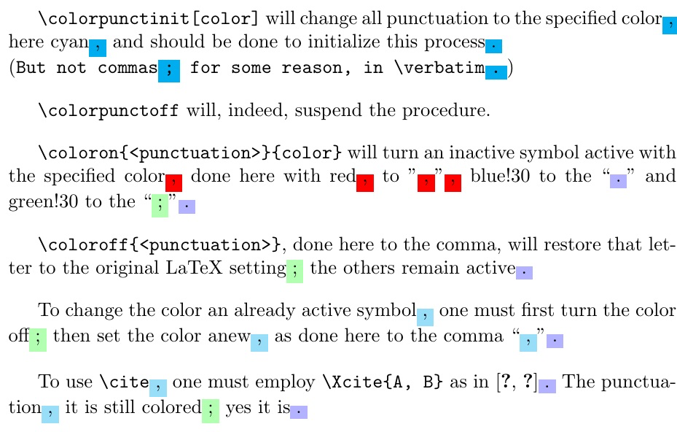
6. 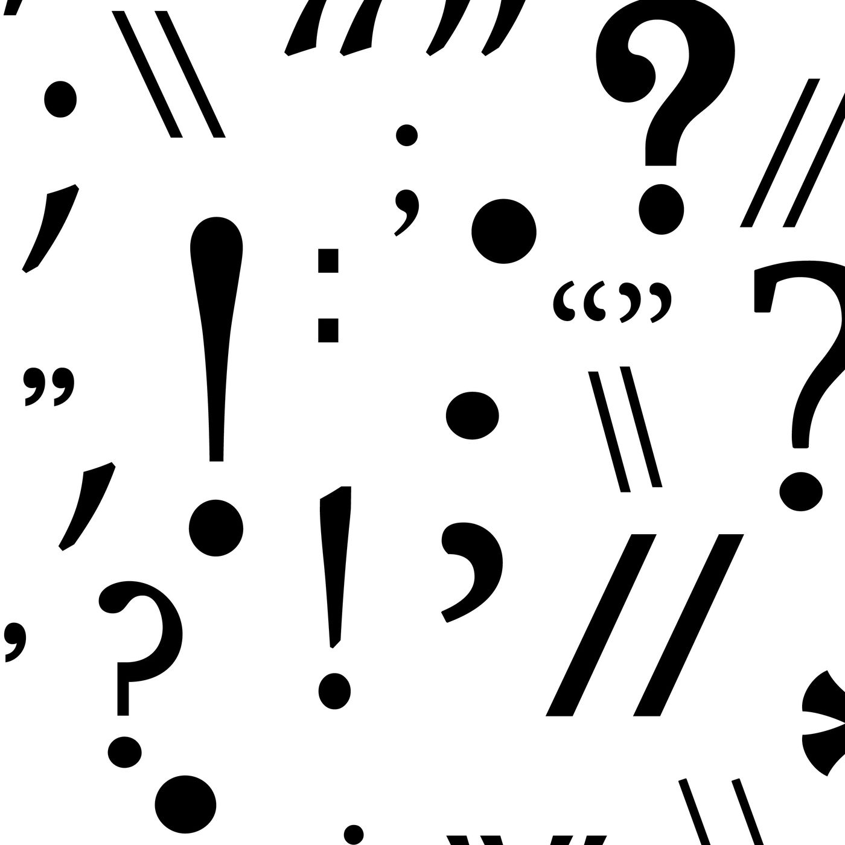
7. 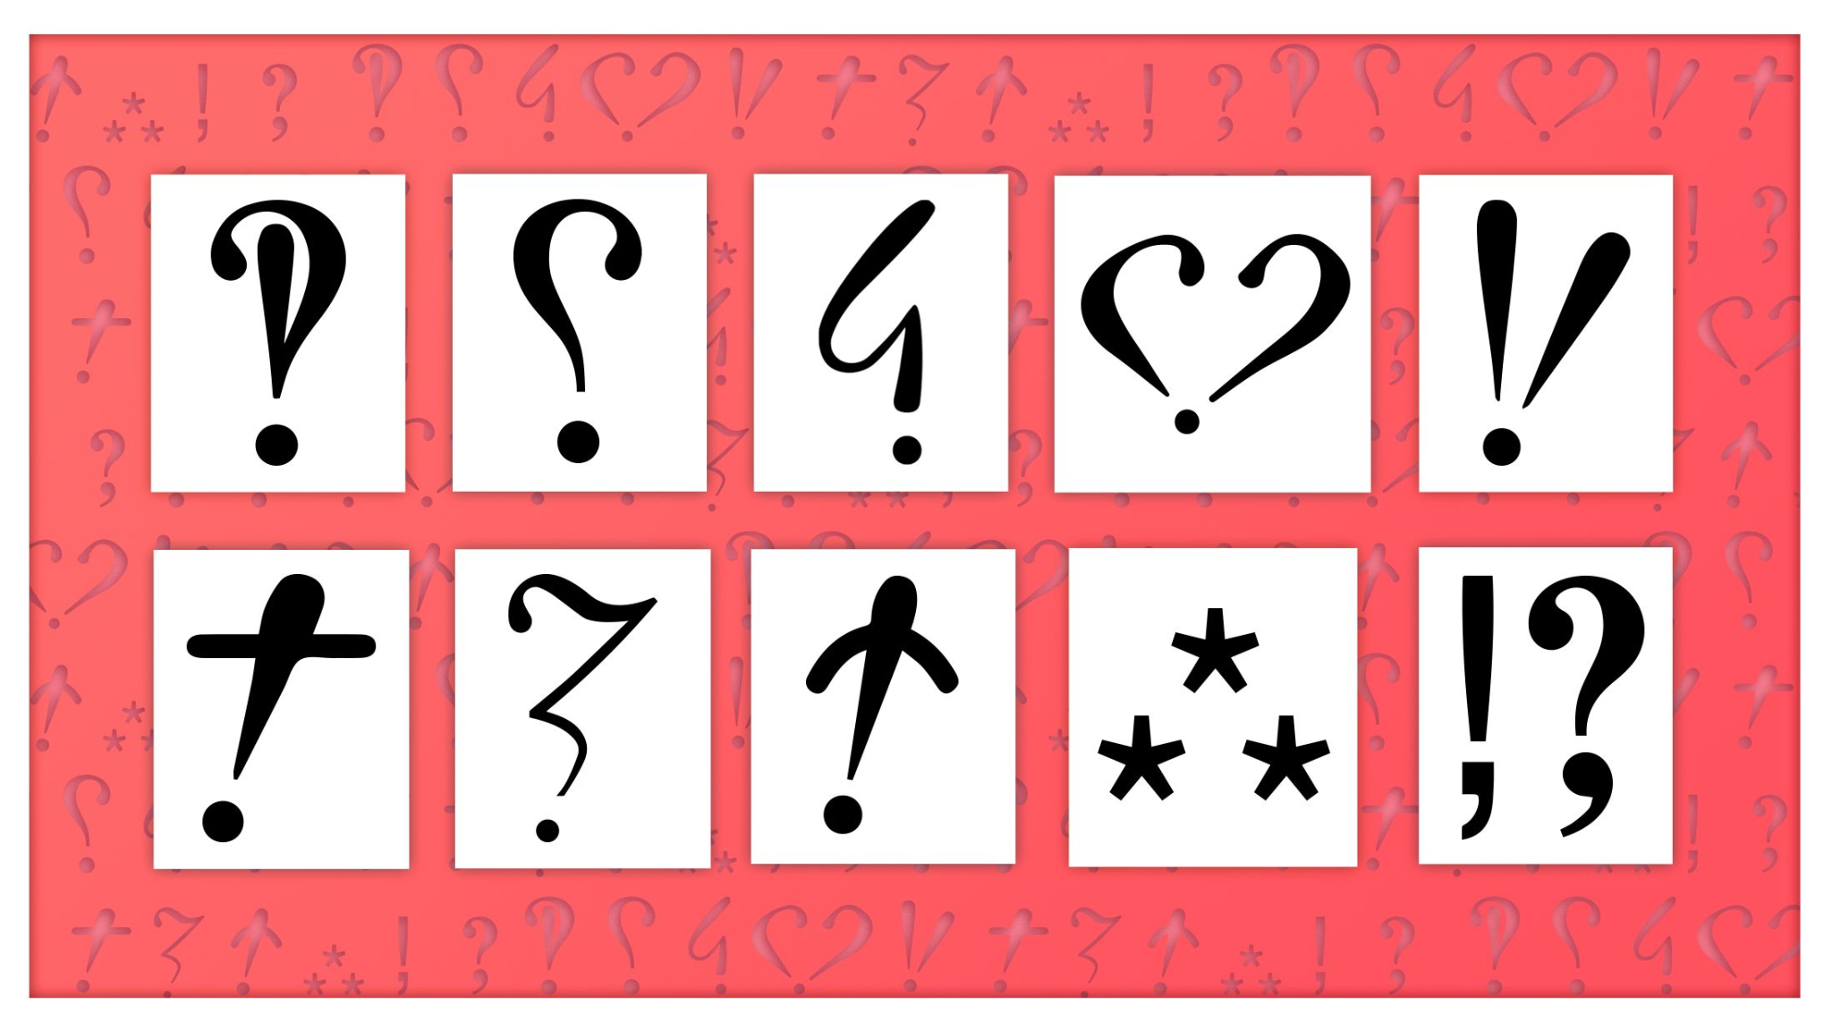
8. Hidden meanings
9. Deeper insight
10. Difference between prose and poems
11. Flowing nature